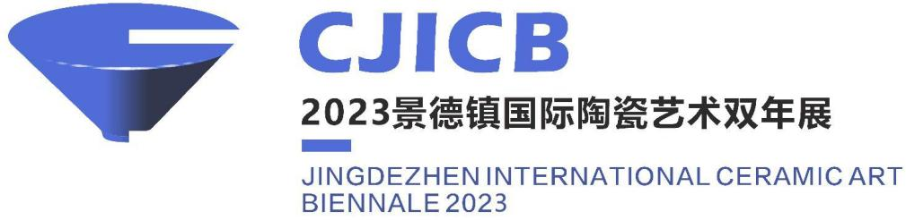
Global Call for Submissions for
The Journey of Ceramics:
2023 Jingdezhen International Ceramic Art Biennale
(Works for Juried Exhibition Section)

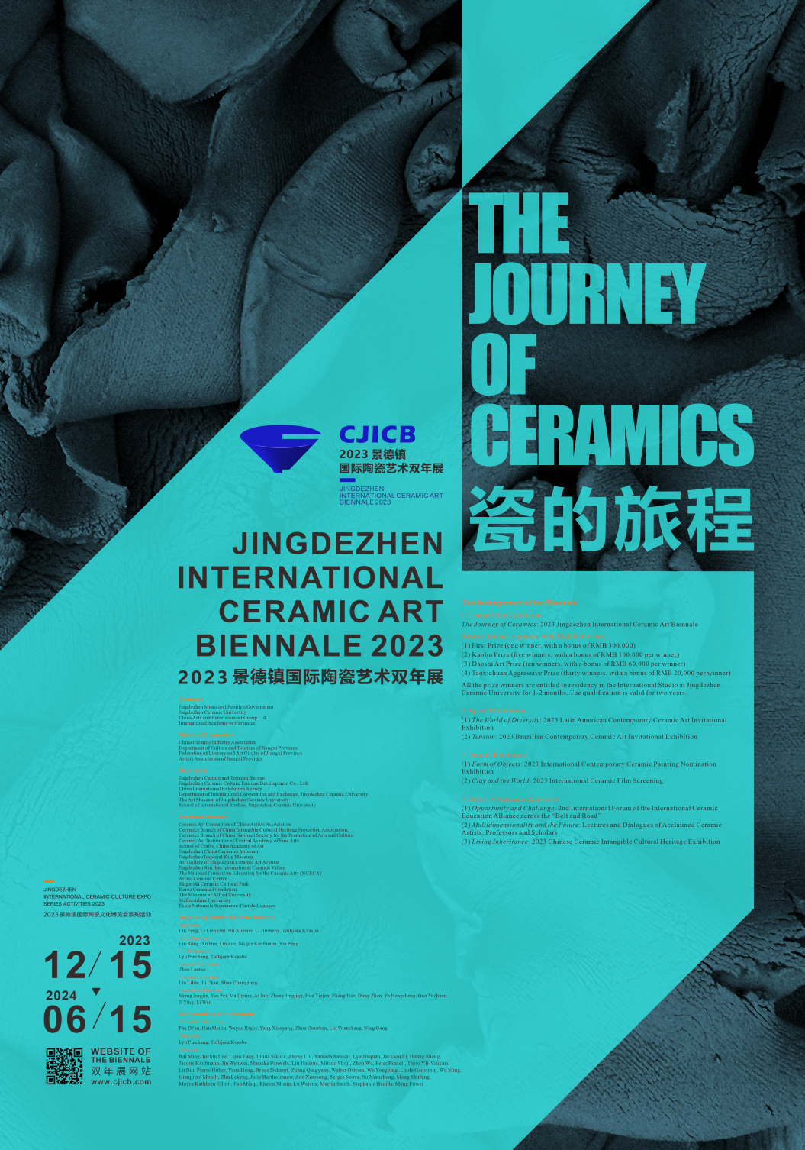
Ceramics is one of the earliest inventions of mankind, and for thousands of years this art of clay and fire has become the most long-lasting link of human civilization, writing the most splendid chapter of global cultural exchanges.

Jingdezhen is a sacred place of world ceramic culture. For thousands of years, exquisite porcelain has set out from here, undergone a long and arduous journey, and finally reached all over the world, becoming the main cultural symbol of China for the world to know. In today's globalized world, let us continue to use ceramics as a medium to perpetuate human curiosity, imagination, and creativity in “the journey of ceramics”.

In order to facilitate the development of the Jingdezhen National Ceramic Culture Inheritance and Innovation Pilot Zone and create a new platform for cultural exchange with other countries, The Journey of Ceramics: 2023 Jingdezhen International Ceramic Art Biennale will be held by Jingdezhen Municipal Government, Jingdezhen Ceramic University, China Arts and Entertainment Group and the International Academy of Ceramics, with the support of the Ministry of Culture and Tourism and the People's Government of Jiangxi Province, based on the foundation of the first Jingdezhen International Ceramic Art Biennale in 2021, The Spirit of Ceramics. The Biennale aims to bring China and the world closer together, presenting the highest level of innovation and development in the world of ceramic culture and art.
The Journey of Ceramics: 2023 Jingdezhen International Ceramic Art Biennale will promote the natural ethics and emotions generated by the interaction between human beings, clay and fire, continue to strengthen the role of ceramics in the integration of ideas and culture, enable artists from all over the world to establish a wider and closer connection, and open up a new journey in ceramic art through the interweaving of internationalization and localization, tradition and modernity.

Sponsors
Jingdezhen Municipal Government
Jingdezhen Ceramic University
International Academy of Ceramics (IAC)
China Arts and Entertainment Group Ltd.

Guidance Counselors
China Ceramic Industry Association
Jiangxi Provincial Department of Culture and Tourism
Federation of Literary and Art Circles of Jiangxi Province
Jiangxi Provincial Artists Association

Organizers
Jingdezhen Culture, Radio, Television, Press, Publication and Tourism Bureau
Jingdezhen Ceramic Culture Tourism Development Co., Ltd.
China International Exhibition Agency
Department of International Cooperation and Exchange, Jingdezhen Ceramic University
Jingdezhen Ceramic University Art Museum
School of International Studies, Jingdezhen Ceramic University

Academic Advisers
Ceramic Art Committee of China Artists Association
Ceramics Branch of China Intangible Cultural Heritage Protection Association
Ceramics Branch of China National Society for the Promotion of Arts and Culture
Ceramic Art Institution of Central Academy of Fine Arts
School of Crafts and Arts, China Academy of Art
Jingdezhen China Ceramics Museum
Jingdezhen Imperial Kiln Museum
Jingdezhen Ceramic Art Avenue Art Gallery
Jingdezhen Sanbao International Ceramic Valley
The National Council on Education for the Ceramic Arts (NCECA)
The Arctic Ceramics Center
Shigaraki Ceramic Cultural Park
Korea Ceramic Foundation
Alfred University Art Museum
Staffordshire University
École Nationale Supérieure d’art de Limoges

Organizing Committee of the Biennale
Directors:
Liu Feng, Secretary of Jingdezhen Municipal Committee of the Communist Party of China (CPC)
Li Liangzhi, Secretary of CPC Party Committee of Jingdezhen Ceramic University
Hu Xuemei, Mayor of Jingdezhen Municipal Government
Li Jinsheng, Secretary and Director of China Arts and Entertainment Group Ltd,
Torbjørn Kvasbø, President of International Academy of Ceramics

Deputy Directors:
Lin Rong, Xu Hui, Liu Zili, Jacque Kaufmann, Yin Peng

Chief Curators:
Lyu Pinchang, Torbjørn Kvasbø

Executive Curator:
Zhao Lantao

Assistant Curators:
Liu Libin, Li Chao, Shao Changzong

Executive Members:
Sheng Jingjin, Yan Pei, Ma Liping, Ai Jun, Zhang Jingjing, Hou Tiejun, Zheng Hao, Dong Zhen, Yu Hongsheng, Guo Yuchuan, Ji Ying, Li Wei

Art Committee of the Biennale
Honorary Directors:
Fan Di'an, Han Meilin, Wayne Higby, Yang Xiaoyang, Zhou Guozhen, Liu Yuanchang, Ning Gang

Directors
Lyu Pinchang, Torbjørn Kvasbø

Members
Bai Ming, Inchin Lee (KOR), Fang Lijun, Linda Sikora (US), Liu Zheng, Yamada Satoshi (JA), Lyu Jinquan, Jackson Li (CAN), Huang Sheng, Jacque Kaufmann (FR), Jin Wenwei, Marieke Pauwels (BE), Liu Jianhua, Mitsuo Shoji (JP), Zhou Wu, Peter Pinnell (US), Tapio Yli-Viiikari (FIN), Lu Bin, Pierre Huber (CH), Yuan Hong, Bruce Dehnert (US), Zhang Qingyuan, Walter Ostrom (CAN), Wu Yongping, Linda Ganstrom (USA), Wu Ming, Gianpiero Moioli (ITA), Zhu Legeng, Julie Bartholomew (AUS), Zou Xiaosong, Sergio Soave (CAN), Meng Shufeng, Moyra Kathleen Elliott (NZ), Fan Minqi, Rheem Misun (KOR), Lu Weisun, Martin Smith (UK), Su Xianzhong,Stephanie Hadida (CH), Meng Fuwei

1. Requirements for Artworks
(1) The exhibited artworks are encouraged to focus on the relationship between community and ceramics, history and ceramics, nations and ceramics, urban space and ceramics, ecology and ceramics, and technology and ceramics.
(2) The Biennale advocates the expression of new materials and new techniques; it encourages cutting-edge technical application to clayworks that reflect their own culture and the cultural inheritance in cross-cultural and cross-regional contexts.
(3) Submitted works are required to be mianly made of ceramic materials (ceramic materials must account for more than 50% of the whole set of works); the size of the works is not limited.

2. Entry Qualification
Ceramic artists from all over the world are encouraged to participate. There are no restrictions on nationality or age.

3. Type of Works and Number of Entries
Vessels/Functional Works 90 (pieces/sets)
Sculptures 90 (pieces/sets)
Installations 30 (pieces/sets)
Ceramic Paintings 40 (pieces/sets)
Video Works 10 (pieces/sets)
Total 260 (pieces/sets)

4. Awards: (bonus is granted with RMB before tax)
(1) First Prize (one winner, with a bonus of RMB 300,000)
(2) Kaolin Prize (five winners, with a bonus of RMB 100,000 per winner)
(3) Dowstone Special Award (ten winners, with a bonus of RMB 60,000 per winner)
(4) Taoxichuan Emerging Artist Award (thirty winners, with a bonus of RMB 20,000 per winner)

5. Website of Jingdezhen International Ceramic Art Biennale
www.cjicb.com

6. Official language
Chinese and English

7. Submission and Selection
The selection will include three stages: submission, preliminary selection and final selection, and the schedule is as follows:

Time | Exhibition Procedures
10th June  -15th August, 2023 | Global Call for Submissions for 2023 CJICB The Journey of Ceramics
15th June-15th October, 2023 | Call for entries of Clay & World: 2023 International Ceramic Film Screening (Independent Exhibitions II) (Please see the submission plan at the Biennale website http://www.cjicb.com.)
Mid-August, 2023 | Announcement to the results of the entries
Late November, 2023 | Announcement to the entries of Clay & World: 2023 International Ceramic Film Screening (Independent Exhibitions II)
Late November, 2023 | On-site jury activities and prize winners announcement
15th December,2023 | The Opening Ceremony of the Biennale

(1) Submission
A. Each author is limited to submit 1 piece/set original ceramic work, in case of collective creation, please apply with one representative (and attach the list of the creative team); the artworks submitted must be original works that have not won any competition awards or been selected by any exhibition; the size of the artworks is not limited; the artworks must be artistic creations mainly made of ceramic materials (ceramic materials must account for more than one-half of the whole set of works).
B. The participant should provide electronic high definition images ≥300 dpi, and the size ≥5MB. Two to three images from different angles of the works should be attached. All images should be based on the principle of monochrome background, appropriate focused, and meeting the potential catalogue printing requirements. Submissions are also required to provide an artist’s working image (≥3M) and it should be titled “xx (exhibiting category) + artist name + nationality + title of the work + size + materials + time of created”.
Requirements for ceramic video work: video format: mp4, avi, mov, rmvb, video quality: more than 720p(1280x720)，time: 2-15 minutes，less than 5G.
C. Method for submitting the works: please download and fill in the application form of the Biennale website: www.cjicb.com and send it together with the work photo, to the following email address info@cjicb.com titled “xx (exhibiting category) + artist name + nationality+ title of the work”.
D. Submission deadline: 24:00 of 10th August 2023 (Beijing time), based on the time of receipt of the email.

(2) Preliminary Selection
The results of the preliminary selection will be announced on the Biennale website www.cjicb.com in mid-August 2023 and the artists will be notified by email or phone call. If you do not receive an email notification within 15 days after the announcement of the results, please check the results of the preliminary selection on the Internet and contact the relevant person immediately by email or telephone.

(3) Final Selection
There will be an onsite-selection at late November 2023 and the results of final selection are expected to be announced then, which will be posted on the Biennale website (http://www.cjicb.com) and the winning authors will be notified by email or telephone.

8. Time of the exhibitions:
From 15th December 2023 to 15th June 2024.

9. Notice to Award Winners
(1) Each participating artist will receive a copy of the catalogue of biennale works and a participating certificate (award certificates for winners) from the organizing committee of the Biennale.
(2) Tax deduction for prizes: The prizes awarded to the winners are subject to personal income tax deduction in accordance with the tax laws of the People's Republic of China.
(3) The winning works of the "First Prize", "Kaolin Prize", "Dowstone Special Award" will be collected by the organizer, and their ownership will belong to the organizer, and a certificate of collection will be issued.
(4) The prizewinning artists shall be obliged to participate in the relevant activities during the opening period (time and matters will be notified separately by contact).
(5) All winners will have the opportunity for the residency at the International Pottery Studio at Jingdezhen Ceramics University for 1-2 months, valid for 2 years, and the specific rules of residency by the International Pottery Studio follow-up contact notice.

10. The Delivery and Insurance of Works
Delivery for the preliminary selection works:
(1) Delivery time: Please send it to Jingdezhen Ceramic University Art Museum of before 18th November 2023.
(2) Package: The participants who receive notification that the work has been selected, must pack the artwork properly with bubble wrap or pearl cotton packaging material before the designated receipt time, and do not use fragile foam board packaging material to secure your work in a wooden box that meets export conditions, (report on the condition of the work, unpacking and display instructions, etc. must be inside the box) and print two copies of the Biennale Artwork Application Form and photos of the work in color, and paste them on the box and inside the box respectively.
(3) Delivery cost: The participant is responsible for transportation, packaging, import and export customs clearance, insurance, and other related costs; the organizing committee is responsible for transportation, import and export customs clearance and related insurance costs for the return of the work.
(4) The artist is welcomed to deliver the work in person to the designated place, please contact the recipient and coordinate the delivery time during working days.

Shipping Address:
The Biennale Office, Jingdezhen Ceramic University Art Museum (Xianghu Campus), Jingdezhen, Jiangxi, China.333403
Recipient
Chen Juan’s phone number: +86 139 7985 6371
Yu Shang’s phone number: +86 189 7985 3205
Tel: 0086-798-8499600 (9:00AM--5:00PM, from Monday to Friday, Beijing Time)

Check and Insurance:
(1) The organizer will take photos and take the initiative to inform the participants when the works are found to be damaged in transit after the works are delivered to the Art Museum of Jingdezhen Ceramic University (or other designated places for the exhibition), and the organizer will not be responsible for any damage to the works and packaging that occurs in transit. To ensure safe shipping, please pack and secure your artwork carefully.
(2) The organizer will be responsible for purchasing insurance during the exhibition period if the work is checked and confirmed to be not damaged.
(3) Insurance period: from the completion of the unboxing inspection, the works will be covered by the organizer's insurance during the selection period, the pre-exhibition period, and the exhibition period (until the deadline for returning the works).
(4) The organizer will take precautions to protect the artworks after receipt. Damage caused by force majeure (e.g., natural disasters) or by factors such as fragile materials or poor construction of the installation, which are the responsibility of the participants, will not be covered by the insurance.
(5) The organizer will purchase insurance for the artworks during the selection and exhibition period, with the principle of ensuring each set of works not exceeding 50,000 RMB (about 7,000 USD).
(6) Under the case of insurance accidents, the organizer must follow the relevant rules of the insurance company.

11. Notice
(1) Participants who complete the application for this exhibition are deemed to have agreed to and followed the provisions of this Biennale.
(2) There may be concentrated application before the application deadline resulting in network congestion. Please be sure to apply early and late application will not be accepted.
(3) No request for the return or replacement of selected works during the selection and exhibition period; please do not participate in other competitions or exhibitions until the selection results are announced.
(4) The sponsors reserve the right to freely and reasonably use, exhibit, study, photograph, video, publish and publicize the participating artists’ portraits and their works.
(5) The artworks must not be counterfeited, plagiarized, or in any way violate copyright laws. If there is any violation of the above provisions, the participant shall be held legally responsible, and the organizer will disqualify him/her from the prize and recover the prize money and relevant certificates. If the reputation of the organizers is damaged by the participants' words or actions, the organizers will pursue their legal responsibilities.
(6) The date, time, regulations, currency, and administrative practice which are mentioned in this document in accordance with the law and regulations of the Republic of China.

Please feel free to contact the Biennale Office for more information.
Email: 054024@jcu.edu.cn (May)

Please see the attached table for the series of academic activities during the Biennale.

Organizing Committee of The Journey of Ceramics:
2023 Jingdezhen International Ceramic Art Biennale
22nd May 2023

Schedule Table:

Events During The Journey of Ceramics: 2023 Jingdezhen International Ceramic Art Biennale
Type | Name | Time | Venue
Main Exhibition | The Journey of Ceramics: 2023 Jingdezhen  International Ceramic Art  Biennale (Competition Exhibition) | From 15th Dec, 2023 to 15th, Jun, 2024 | Jingdezhen Ceramic University Art Museum
Regional and International Invitational Exhibition | 1. The World of Diversity: 2023 Latin American Contemporary Ceramic Art Invitational Exhibition | 18th Oct, 2023 to 15th Jun, 2024 | Jingdezhen Ceramic Expo Center
 | 2. "Expanding" - 2023 Brazilian Contemporary Ceramic Art Invitational Exhibition | 18th Oct, 2023 to 15th Jun, 2024 | Art Gallery of Jingdezhen Taoxichuan Ceramic Art Avenue
Parallel Exhibition | 1. Independent Exhibitions I: Form of Objects 2023 International Contemporary Ceramic Painting Nomination Exhibition | From 15th Dec, 2023 to 15th, Jun, 2024 | Jingdezhen Sanbao Cultural and Creative Center Art Museum
 | 2. Clay & World: 2023 International Ceramic Film Screening | From 15th Dec, 2023 to 25th, Jun, 2023 | Jingdezhen China Ceramics Museum conference hall, Jingdezhen Imperial Kiln Museum conference hall, Art Gallery of Jingdezhen Ceramic Art Avenue conference hall, Jingdezhen Ceramic University graduate laboratory building report hall, Jingdezhen SanBaoPeng Art Museum
Academic Activity Series | 1. Opportunity and Challenge: 2nd International Forum of Ceramic Road International Ceramic Education Alliance | From 15th Dec, 2023 to 17th, Jun, 2023 | Jingdezhen Ceramic University International Academic Report Hall, Jingdezhen Ceramic University graduate laboratory building report hall
 | 2. Multidimensionality and the Future: Lectures and Panel Discussions of Acclaimed Ceramic Artists, Professors and Scholars | From 15th Dec, 2023 to 17th, Jun, 2023 | Jingdezhen SanBaoPeng Art Museum conference hall, Art Gallery of Jingdezhen Ceramic Art Avenue conference hall, Jingdezhen University conference hall, Jingdezhen China Ceramics Museum conference hall, Jingdezhen Imperial Kiln Museum conference hall, Jingdezhen Ceramic University International Academic Report Hall, Jingdezhen Ceramic University graduate laboratory building report hall
 | 3. "Living Inheritance": 2023 Chinese Ceramic Intangible Cultural Heritage Exhibition and Demonstrations | From 15th Dec, 2023 to 17th, Jun, 2023 | The Art Museum of Jingdezhen Ceramic University

